Title: skiba: a forester’s app to perform point extractions from Google Earth Engine
Authors: Tara Skiba, Tyler Gifford, Chris Mihair, Thomas Brandeis
Journal of interest: Forestry (Oxford Academic)
Citable Nuggets
- Remotely sensed data can be easier to incorporate into forest studies and inventories if technological barriers are removed
- Existing Python packages can be combined to develop a more efficient workflow to extract pixel values from remotely sensed data in GEE.
- Due to concerns about running sensitive coordinates through GEE, two buffering approaches were developed to use in conjunction with point extraction tools.
Abstract
The skiba Python and Streamlit web applications are designed to help expand forest inventories and studies through integrating Google Earth Engine’s plethora of geospatial data without extensive geospatial knowledge requirements. Technical challenges regarding handling geospatial data remain a major barrier that has prevented the uptake of geospatial data into forestry fields, despite the advantages that geospatial data can provide. Google Earth Engine, which is a large, publicly available database of popular geospatial data, can be leveraged along with existing geospatial technologies to remove many of the existing barriers to accessing and handling geospatial datasets, which will allow geospatial data to be more easily integrated into forest management/studies/etc.
Introduction
Forests are complex, highly variable systems whose structure and dynamics are shaped by environmental conditions that are often difficult to measure at meaningful spatial scales (Toledo et al. 2011, Itter et al. 2017, Wei et al. 2025). Operational inventories, like national forest inventories, are designed to capture tree and stand characteristics across large scales and at high resolution, but they typically lack detailed environmental data, despite its known influence on forest systems. They are excluded because collection methods to produce long-term environmental data are time-consuming and expensive for small areas and impossible for large scale forest inventories (Thammanu et al. 2020). This absence reflects both logistical and conceptual constraints: collecting long-term environmental data is time-consuming and costly in small areas, and becomes impossible at the scale of forest inventories, while the primary goal of these programs is to quantify forest structure rather than environmental conditions. As a result, foresters seeking to include environmental data into research or management have increasingly turned to geospatial data to fill these gaps. Geospatial data provide continuous, long-term records of environmental or climate variables and capture metrics that are best measured remotely, such as the Normalized Difference Vegetation Index derived from Landsat’s multi-spectral imagery (Chi et al. 2016, Chinembiri Tsikai Solomon, Mutanga, and Dube 2022, Yang et al. 2022, Chinembiri Tsikai S., Mutanga, and Dube 2024, Jha et al. 2024). The most notable strength of geospatial data is its temporal and spatial continuity over large areas, which allows for easy integration into forest inventories. Thus, while existing forest inventories remain a crucial part of a forester’s toolbox, estimations of forest health, biomass, and disturbance, and climate drivers are substantially improved with the inclusion of geospatial data.
The specialized technical knowledge needed to utilize geospatial technologies poses a significant barrier for foresters to overcome, thereby preventing geospatial data from being used to its fullest potential (Ziegler and Chasins 2023, Fassnacht et al. 2024). Existing geospatial processing technologies are powerful but still require geospatial literacy and programming skills. Geospatial software like ArcGIS eliminates the majority of the programming knowledge needed through its program interface which makes it a popular software within natural resources, but users must still have geospatial data knowledge to perform any operations (Morgenroth and Visser 2013). In addition, licenses may have to be purchased, which can be expensive and deter potential users. Open-source programs like Python and R provide the most user flexibility with geospatial data handling but are more technically advanced due to the programming required. Even if users have the required technical knowledge and software available, other challenges remain.
One major obstacle is the decentralization of data, as geospatial datasets are collected and maintained by numerous government agencies, both domestically and internationally. These datasets are hosted among the various agencies’ websites, which can pose issues not only with locating the desired dataset, but also with downloading these incredibly large datasets. These challenges can make geospatial data retrieval, handling, and processing inefficient.
A solution to the issue of data decentralization can be found when using Google Earth Engine (GEE), a free, public repository of many popular remotely sensed and other geospatial datasets (Mutanga and Kumar 2019). Datasets are stored in a cloud server, which allow users to avoid having to download the large datasets locally, increasing efficiency. GEE also has a Code Editor where users can work completely on a cloud server and employs the JavaScript language (Amani et al. 2020, Ermida et al. 2020). For non-JavaScript users, GEE has been integrated into existing geospatial analysis software. The GEE Toolbox provides GEE integration in ArcGIS products (Google Earth Engine Community [2024] 2026). The R package rgee provides GEE integration into the R environment by translating R code to Python and passing it to the Google Earth Engine API (Aybar et al. 2020). Meanwhile, earthengine-api (ee) in Python provides users the full processing flexibility similar to GEE’s Code Editor, and Python packages like geemap provides additional functions that streamline the processing workflow (Wu 2020, Google Earth Engine, n.d.). Such tools provide easier access to GEE and reduce some of the legwork needed to perform geospatial analysis, but the technical threshold for manipulating geospatial data remains.
One way for geospatial data to be paired with operational forest inventories is to perform simple point extractions of the pixel value that contains an inventory plot’s coordinates. To accomplish this, users would have to upload their coordinates, access GEE and select a dataset, perform any necessary data manipulations to ensure object (file, format) compatibility, extract the desired information, and return the results. While these point extractions are possible to produce with existing software, there is a need to make this process more efficient and less technically complicated. This entire workflow can be distilled down to only require the user to provide the necessary input information and perform all other steps behind the scenes. The creation of a streamlined workflow would not only be beneficial to foresters lacking the technical knowledge to access geospatial data, but it would also allow experienced geospatial data users to perform simple point extractions quickly and efficiently.
Because forest inventories can contain highly detailed information of public and private lands, which can also be used to estimate the monetary value of the existing timber, actual plot coordinates may be protected under confidentiality agreements to preserve plot integrity and protect private landowners’ properties. These confidentiality agreements may not allow data users to run these protected coordinates through GEE without modification. The U.S.’s national forest inventory, which is maintained by the USDA U.S. Forest Service’s Forest Inventory and Analysis program, provides publicly available coordinates that are buffered using the methodology described in the (General Technical Report WO 2005). Proprietary or other government forest inventories may not have an established buffering methodology as these datasets are not publicly accessible. Users of these datasets may have concerns about using unprotected plot coordinates in GEE, given the public nature of Google services. To alleviate these concerns, a buffering approach that quickly creates randomized plot coordinates within radius r of the raw plot coordinate. The randomization of plots coordinates safely hides actual plot coordinates to be run in GEE.
Currently, a streamlined workflow that allows forest practitioners to specifically perform point-extractions from GEE-derived raster data for inventory coordinates without advanced coding or proprietary software does not exist. In this study, the skiba Python app was developed to combine existing GEE Python packages into a system that minimizes the coding requirements and lowers the technical threshold previously needed. The goal of this project is to alleviate setup time to perform point extractions and reduce the number of steps required to access and retrieve data from Google Earth Engine in order for geospatial data to more efficiently be integrated into forest studies and inventories. The combinations of point extraction and point buffering workflows developed reduce the time and required skills for foresters to incorporate RS data into forest studies and inventories.
Methods
Software design
The skiba Python app was designed for users to reduce technical barriers for accessing Google Earth Engine and producing point extractions. The returned point extractions can be integrated into forest operations to increase the scope of information that can be used in existing forest inventories and studies. The skiba app addresses privacy concerns regarding sensitive plot coordinates by providing two buffering methodologies. To lower the technical threshold needed to perform all operations, we designed this app to create a user interface consisting of point-and-click widgets. This design interface handles file uploading, coordinate processing, and file returns, so that app users need only to simply load the modules and provide the information needed. The workflows created, while designed to remove technical barriers involved, can also provide efficient alternatives to existing approaches through decreased set-up time and quick processing.
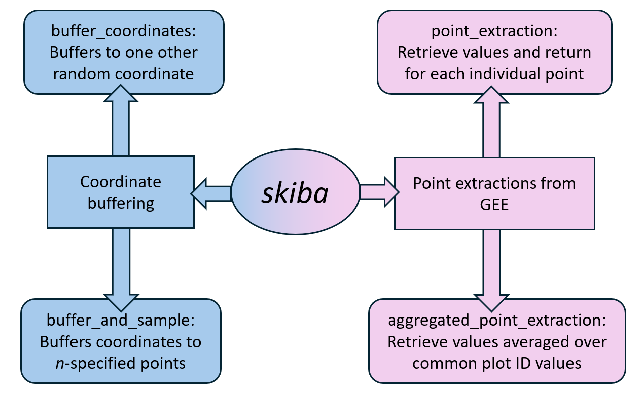
The app is divided into two task groups: point extractions and coordinate buffering, which can be visualized in Figure 1. The point extraction approaches access and retrieve information from GEE, while the coordinate buffering approaches provide the option to safeguard confidential plot coordinates prior to point extraction. Each task group contains two modules, for a total of four created modules. This app relies on a number of dependencies. The ipywidgets app serves as the foundation for all modules to construct the front-end user interface to provide a point-and-click workflow without extensive data handling and coding (Martindale et al. 2024). Pandas and geopandas are leveraged in each module to handle geospatial file handling throughout the algorithm. The ee and geemap Python packages are exclusively called within the point extraction modules to handle Google Earth Engine objects and retrieve pixel values. In the buffering approaches, shapely, shapely.geometry, pyproj, and numpy help generate random coordinate points. As the buffering modules’ packages do not access GEE, coordinate points run through these buffering modules are protected from Google.
Figure 1: Diagram of package structure
Formatting for Plot Coordinates File
The user-provided file of coordinate points to run through all modules must be properly formatted to prevent data handling errors. This file must be saved as a CSV file and contain the three following columns: a plot identifier column, a latitude column, and a longitude column. Accepted naming conventions for these columns are shown in Table 1. (Additional columns may be present but may be discarded or modified by the The plot identifier column is used as a reference column that is grouped over in the point creation and averaging processes conducted in the buffer_and_sample and aggregated_point_extraction modules. Latitude and longitude columns should be formatted in decimal degrees.
Point Extraction Modules
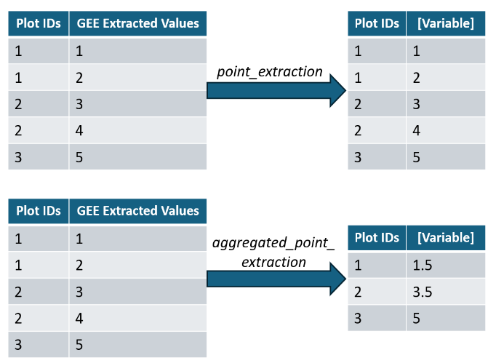
The point extraction modules contain processes to perform pixel extractions from GEE datasets. As it accesses Google Earth Engine internally, GEE must be initialized and authenticated as described in the GEE Python documentation prior to running any query. Once a point extraction module is loaded, the user will only need to complete two steps: upload a data file of coordinate points, and select the desired GEE dataset from the drop-down widget along with the date filter, if applicable.
Figure 2: Demonstration of how data aggregations differ for the two point-extraction modules.
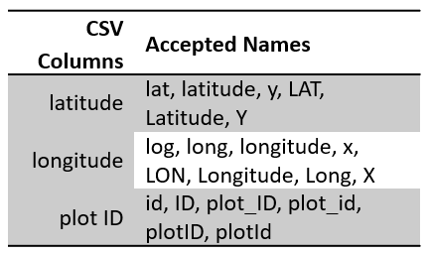
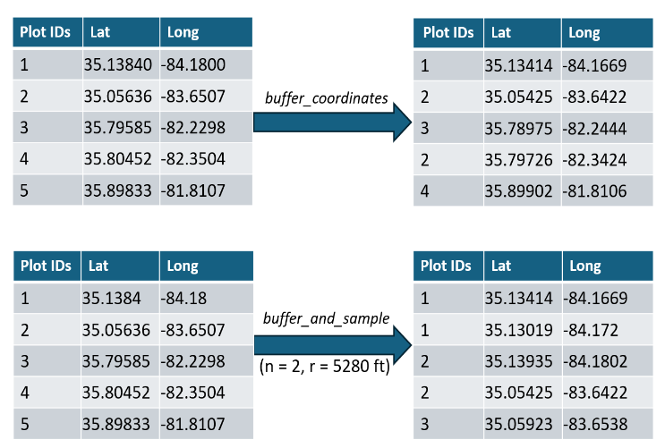
The modules’ inputs have certain criteria/conditions. In the first step, the data set of coordinates must follow the formatting criteria described in the Data Formatting section above. In step two, acceptable GEE datasets must be classified as Images, which are raster datasets, or a stack of Images called ImageCollections, but not FeatureCollections. Due to the design of the app’s data filtering process, the additional data filtering and handling capabilities needed to filter ImageCollections with additional properties or FeatureCollections are absent. Acceptable ImageCollections require start and end dates, which can be either the dataset’s entire availability or a specified time frame. Images do not require time filters due to their single image propertry. Information about a dataset’s classification as an Image, ImageCollection, or FeatureCollection, its temporal availability, and additional image properties can be found on the dataset’s GEE documentation page. The link to the documentation is conveniently provided once a dataset is selected from the drop-down menu. Additional limitations may exist but have not yet been identified.
Table 1: Accepted column names for user-provided list of coordinates. File must be saved as a CSV.
Figure 3: Demonstration of point creation differences for the two coordinate buffering modules.
Two point-extraction modules that follow this general framework were created: point_extraction and aggregated_point_extraction. Both modules perform the same extraction process but differ in aggregation technique. point_extraction returns the extracted data for each coordinate uploaded, whereas aggregated_point_extraction extracts the pixel values then averages over shared plot IDs. The difference between returned results is demonstrated in Figure 2. The following script is used to initialize GEE and load the point extraction modules:
import ee
# Initialize Earth Engine
ee.Authenticate()
ee.Initialize(project="[your project name]")
# For non-aggregated point extraction (point_extraction)
import skiba.point_extraction as spe
point = spe.PointExtraction().vbox
point
# For aggregated point extraction (aggregated_point_extraction)
import skiba.aggregated_point_extraction as sape
agg = sape.AggregatedPointExtraction().vbox
agg
Coordinate Buffering Modules
Users who have concerns about operating GEE using sensitive plot coordinates can first run their coordinates through one of two buffering approaches created to quickly generate randomized coordinates within a defined radius. Randomized coordinates can then be appliedin the point extraction modules. The buffering modules are called separately from the point extraction modules, and as they do not initialize GEE, coordinates are hidden from GEE. Like the point extraction modules, these buffering modules only require two steps: users provide a correctly formatted CSV file of raw coordinates, then set the buffer radius and optionally, the number of randomized coordinates to generate. The returned dataset is returned correctly formatted for the point extraction modules with the original coordinates removed.
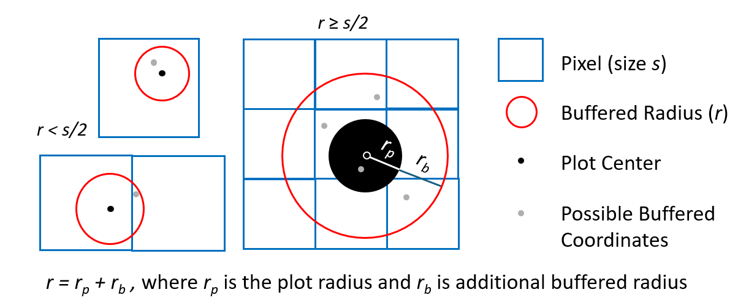
Two modules were created to buffer sensitive coordinates. Both modules follow the same randomization process: buffered coordinates generated at a randomized angle and distance within r. The difference between the two modules lies in how many randomized coordinates are generated, seen in Figure 3. buffer_coordinates produces one randomized coordinate for each user-provided coordinate; buffer_and_sample returns n random coordinates for each provided coordinate, where n is an integer provided by the user. A visualization of this buffering approach is provided in.
Figure 4: Examples of where randomized pixels may be created in pixels different from the original coordinate
Setting buffer radius r for randomized points to be generated within can be determined by consulting the data’s user guide, the pixel size for the GEE dataset of interest, and user discretion. Additionally, if the plot radius is considerably large, it may need to be considered when determining an appropriate buffer radius. Note that pixel values extracted using buffered coordinates could return biased results. Some visual examples of how buffered coordinates may lie outside of the original coordinate’s pixel are shown in. This is demonstrated in Figures 4 and 5, where some buffered coordinates lie in a neighboring pixel. Users may desire to repeat the buffering process and point extractions to compare differences in returned values and determine if the values are acceptable. A case study investigates the severity of these biases/differences in Section []. The following script is used to load the point buffering modules:
# For single point buffering (buffer_coordinates)
import skiba.buffer_coordinates as sbc
single = sbc.buffer_coordinates().vbox
single
# For multiple point buffering (buffer_and_sample)
import skiba.buffer_and_sample as sbs
multiple = sbs.buffer().vbox
multiple
Workflow
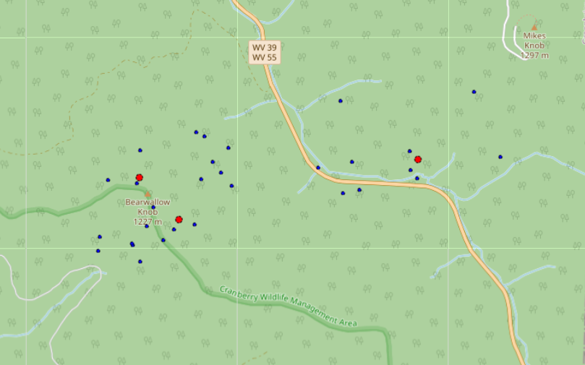
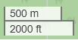
User workflows for the skiba app depend on the desired returned data. The overall simple workflow is shown in Figure 6. The first step is whether or not to buffer the coordinates. While both buffering approaches protect the uploaded coordinates, the buffer_and_sample module can be used to sample from an area. For example, if a user is interested in sampling from a large area, they can upload a central coordinate, and sample n points within the area of interest to produce area-level estimates. After the optional buffering is conducted, the point extraction method selected will depend on how the user wants the data returned. While the buffer_coordinates module was designed to complement the point_extraction module, and likewise, buffer_and_sample complements aggregated_point_extraction, users may be interested in examining the individual values returned by multi-point buffered coordinates. Therefore, coordinates buffered through buffer_and_sample can be used in point_extraction, and user-provided datasets that contain shared plot ID values can be run through aggregated_point_extraction to quickly aggregate results over the shared values. A diagram of all potential workflow options is shown in Figure 7.
Figure 5: Example of buffer_and_sample approach with r = 3000 ft and n = 10. Uploaded coordinates are marked red, and the 10 buffered coordinates are blue.
Methodological limitations
Limitations exist regarding datasetcompatibility. For example, WorldClim Climatology V1 (WORLDCLIM/V1/MONTHLY) and NEON Canopy Height Model (projects/neon-prod-earthengine/assets/CHM/001) are both ImageCollections, which can be handled by the created modules. However, both datasets contain metadata fields attached to the collection objects themselves called Image Properties, which are used to filter, sort, and select images. This changes the process for filtering GEE datasets and was not accounted for/considered in the design process of the skiba app. Therefore, GEE ImageCollections that contain Image Properties are incompatible with this app.
Streamlit web app
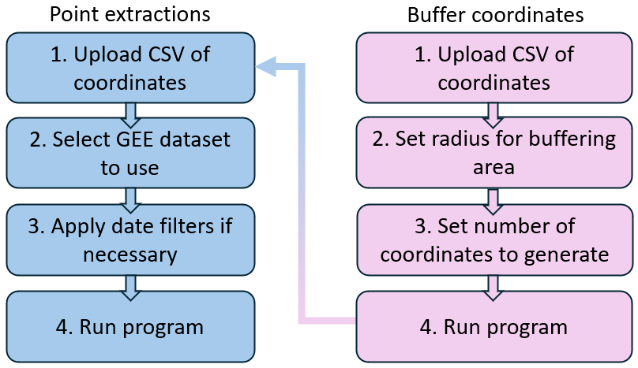
While the skiba Python app removes many technical barriers and streamlines coordinate buffering and point extraction processes, the required Python skills needed to operate this app is enough to still deter users from utilizing this app. To remove any remaining coding requirements, a web application hosted on Streamlit was created that contains the same modules as the Python app but with some differences in the back-end development.
Figure 6: General framework for application use
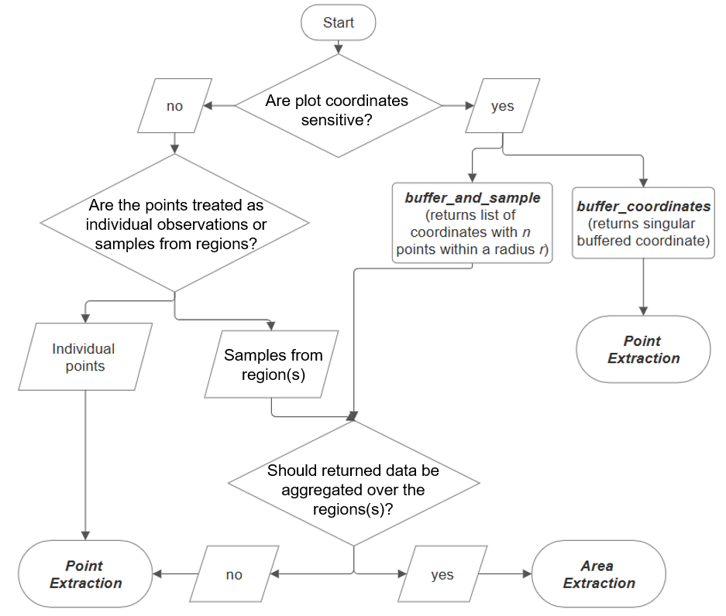
While each of the four modules in the Python app is recreated in the web app, there are structural differences due to ipywidgets not being compatible with Streamlit. Streamlit offers its own collection of widgets. Therefore, the web app is a recreation of the Python package within a Streamlit environment, and the Python package is not called within the web app. A significant impact of this is that the web app will lag behind the Python app’s functionality until the web app is manually updated.
Figure 7: Complete workflow options for module use.
In addition, GEE is initialized through a pre-designated Google account held by the app maintainer, and web app users are not able to use their own Google Earth Engine Project, unlike in the Python app, where GEE is manually initialized with a user-owned account. This is notable particularly when users with sensitive plot coordinates are only permitted to run raw coordinates through an approved Google account. Debugging error messages is also difficult since the detailed error codes are only visible to maintainers.
While limitations exist with the web application that can be improved in the future, the major advantages are that all coding requirements are removed, in turn increasing accessibility to users with limited coding knowledge, and it is accessible from any computer with internet access, without requiring a Python environment to run.
Case study – Forest Inventory
We demonstrate the utility of the skiba app through comparing elevation values extracted from the point extraction modules against reported values from a forest inventory and quantifying the differences of returned values produced via the different buffering approaches developed. To validate the point extraction modules, we compared recorded values against queried values. We evaluated the differences in returned values produced by the buffering approaches against true plot values to investigate if the buffering approaches reduce estimation bias. The U.S. Forest Service Forest Inventory and Analysis’s (FIA) long-term forest monitoring inventory was selected to demonstrate how this application can supplement operational forest inventories.

The FIA’s forest monitoring program serves as the United States’ national forest inventory and is prominently used in forest studies to provide stand-level metrics and as validation data. The FIA’s forest plots are ~1 ac plot containing tree and stand level measurements that are remeasured at various intervals depending on the region. Plot coordinates are recorded at plot center [of the subplot (I don’t know if this is right)]. To preserve the integrity of this forest monitoring program and protect private landowners’ information, exact plot coordinates are classified. To compensate for the protected coordinates, the FIA provides publicly available coordinates that are buffered between a half to a 1-mile radius, with an additional swapping of plot identifiers for plots located on privately owned lands. The full methodology for this process can be found in (Bechtold and Patterson 2015). For this case study, we obtained both the public and confidential plot coordinates. As only coordinates located within public lands of national forests and parks of southern Appalachia are used, the public plot coordinates are only buffered. Therefore, we did not need to correct for swapped plot identifiers in our analysis.
Point extraction study with elevation data

To evaluate the accuracy of the point extraction modules, we examined the FIA reported elevation values against the NASA SRTM Digital Elevation 30m dataset available on Google Earth Engine. The NASA dataset’s availability is from February 11th to 22nd of 2000, which overlaps with the time range of FIA observations, which ranges from 1997 until 2023. We assume that minimal changes in elevation have occurred due to the limited management on public lands, but some changes may have occurred due natural disasters such as flooding or landslides. In order to run the protected plot coordinates through the point extraction modules, the plot coordinates were first buffered using buffer_coordinates, then the private and buffered coordinates were merged to run through the point_extraction module. The buffered coordinate values were then filtered out. Returned elevation values were converted from meters to feet to match the FIA’s elevation units. The average percent difference and average absolute difference between the NASA dataset and FIA dataset, with the latter used as the observed values, were calculated for 2,694 observations.
Buffering approach study with environmental data
While the FIA provides public plot coordinates, running these coordinates through the point extraction modules may return biased results, and the amount of bias introduced is GEE dataset dependent on characteristics like pixel size. To demonstrate the advantage of taking extra time to run confidential coordinates through the developed buffering approaches and showcase how the buffering approaches can be used to supplement the FIA dataset, we use the various buffering approaches in tandem with the point extraction module to supplement forest inventories with environmental data. The WorldClim BIO variables V1 dataset in GEE is commonly used to provide environmental data in existing forest studies, especially as a supplement to FIA data. It contains 19 variables of various climate metrics pertaining to precipitation and temperature (Table 2) at a gridded spatial resolution of 927.67 meters (~1 km), which is compatible with the FIA’s permanent plot size (Marchi et al. 2019, Wertz and Wilczyński 2022, Yang et al. 2022, Gou et al. 2025). Its time availability spans from Jan. 1, 1960 – Jan.1, 1991. As the distances between public and private plot coordinates typically range between 0.5 and 1 mile (804.67 – 1609.34 m), the public and private plot coordinates may lie in adjacent pixels, yielding biased values produced by pixel extractions.
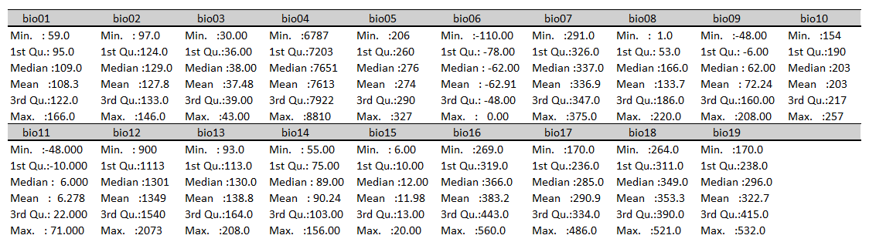
In this portion of our case study, we compared the differences in returned values against the private FIA coordinates for three datasets: one dataset of the public FIA plot coordinates and one dataset from each of the two buffering approaches, buffered using the private FIA coordinates. Buffered coordinates from private FIA coordinates were generated within a 1-mi radius, similar to how the FIA’s public coordinates are generated. One buffered dataset contains the coordinates from a single point buffer, and the other contains multi-point buffering using buffer_and_sample module with n=10. Using the raw dataset as the baseline, the average percent differences and average absolute differences were calculated from the 2,694 plot coordinates for all 19 WorldClim bio-variables. We calculated the relative and absolute differences for each the raw, single buffered, and 10-point buffered datasets compared to the raw dataset. In addition, the coefficients of variation calculated quantify the variance within the multi-point buffered points for each plot and is used to understand the range of values within each plot’s multi-point buffered coordinates.
Table 2: Summary statistics from 10 buffered coordinates dataset. Note: bio01 – bio07 are unscaled, as described in variable description table.
Table 3: WorldClim BIO variables and description
Results
Point extraction with elevation data
Our analysis of the point extraction modules using recorded elevation from FIA data and elevation values queried from the NASA dataset show that values are approximately the same, with some inaccuracies present. While the distributions of both datasets are approximately the same (Figure 8), when looking at the fitted graph of the two datasets (Figure 9), we can observe some of these extreme inaccuracies. In Figure x, one plot that has an FIA recorded elevation of approximately 1,400 ft has a queried NASA elevation of approximately 5,600 ft. Some justifications for such extreme differences could be topological changes that occurred after the NASA dataset was created. Some of the less extreme inaccuracies could possibly be explained by the non-smooth transition that elevations can follow, particularly in a region characterized by steep mountains and rocky bluffs.
Even though some extreme outliers exist, overall, the FIA and NASA elevation values follow the 1:1 vertical line to confirm that the point extraction modules function as designed. Table 4 shows that the average absolute difference is 215.5 ft and an average percent difference of 3.88%. An average absolute difference of 215.5 ft would be considerable at lower elevations, given the topography of the region that this analysis was conducted on, it may not be significant. Repeating this analysis with another GEE elevation dataset may produce improved results.
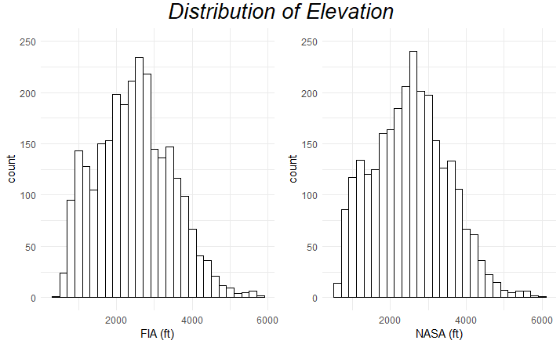
Buffering approach with environmental data
Figure 8: Distributions of elevation values recorded in the FIA database and queried from the NASA SRTM dataset.
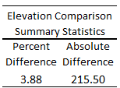
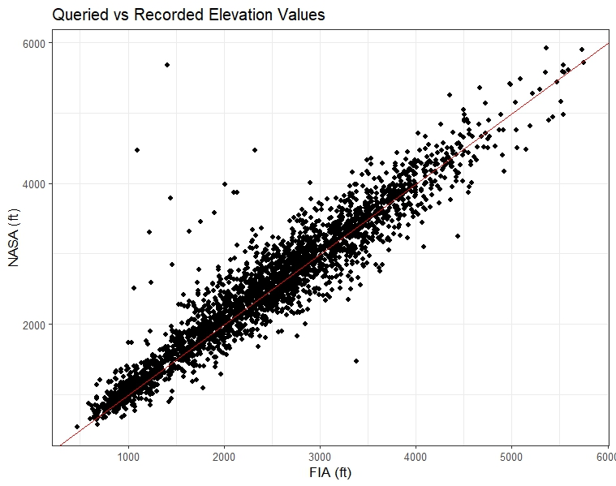
Percent differences and absolute differences calculated between the various buffered datasets are shown in Table 5. Both buffering approaches reduce the relative difference between the buffered and raw values, with almost all variables from both buffering approaches having less than a 1% difference. Two variables did not have less biased results than the public coordinates: biovars 9 (mean temperature of driest quarter) and 11 (mean temperature of coldest quarter). The magnitude of differences in value is shown in the table of average absolute differences, with differences ranging from less than 1 up to 25 with units varying by biovariable. These absolute differences can be cross-examined with the summary statistics from the 10-point buffered coordinate summary table to contextualize the magnitudes of the difference. Upon further examination of the absolute differences table, we can see that taking the average value of multiple buffered coordinates consistently produced values closer to true plot values. The discrepancies between the percent differences and absolute differences results can be explained by the removal of infinite values and NA values when calculating the average absolute differences. The last column in Table 5 shows the average coefficient of variation within plots’ 10 buffered coordinates, and all coefficients of variation produced are less than 10%, well within the accepted range to conclude that the dataset has low variation and high consistency. Despite the low variation within each plot’s buffered coordinates’ values, the averaging process of the multi-point buffering approach reduces the numerical difference to raw dataset.
Table 4: Summary Statistics of Comparison between recorded FIA and queried NASA elevation data
Figure 9: Fitted graph of queried vs recorded elevation values.
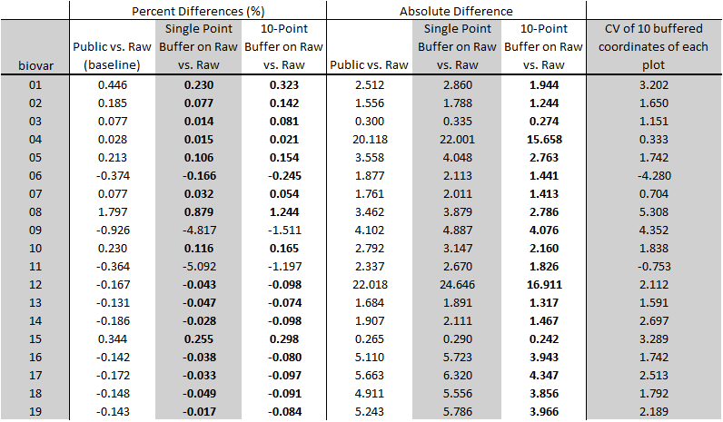
These improvement values of both buffering approaches may be explained by the difference in how the public FIA coordinates and created buffered coordinates are generated. While the public FIA coordinates are 0.5-1 miles away from the actual plot coordinates, the coordinates generated via either buffering approach can be created closer than 0.5 miles from the uploaded coordinate. Furthermore, because environmental datasets like WorldClim have gradual transitions across areas. The combination of these two factors can result in less biased results than using public coordinates. The multi-buffered approach produces values closest to the true value.
Table 5: Average percent and absolute differences of public, single buffered point, and 10 buffered points against raw data for all WorldClim BIO variables (raw data is used as the baseline or observed values). Bolded numbers are differences smaller than the baseline. The averaged coefficients of variance within the 10 buffered points for each plot are shown for each WorldClim BIO variable.
The two analyses performed also show how differences in landscape features, like gradual transitions between environmental conditions versus stark differences in elevation appear. These results show that both buffering approaches used return values closer to those of the true plot location than using the publicly available data.
Conclusions
As forest management and studies continue to cover larger spatial and temporal scales, geospatial techniques will be required to accomplish these goals. Therefore, it is imperative to increase user-friendliness with accessing and utilizing the plethora of geospatial data available. The skiba Python application was developed to remove technical challenges required to perform point extractions from Google Earth Engine and buffer sensitive coordinates to run through Google servers. By developing a widget-oriented application, many of the technical skills needed to access and handle Google Earth Engine raster datasets are removed. The supplemental web application on Streamlit removes the remaining coding skills needed in order to further increase user accessibility. This app has an open-source repository on GitHub and is downloadable from PyPI using the following command:
# install skiba
pip install skiba
As this app is hosted on GitHub, users have the option to expand functionality to fit additional needs, such as GEE dataset handling and other issues mentioned. Despite these limitations, a framework has been established to demonstrate how to remove technical complexities with using geospatial data. This application can be further expanded to increase user accessibility and the uptake of geospatial data among foresters and other natural resource professionals.

References
Amani M, Ghorbanian A, Ahmadi SA et al. Google Earth Engine Cloud Computing Platform for Remote Sensing Big Data Applications: A Comprehensive Review. IEEE Journal of Selected Topics in Applied Earth Observations and Remote Sensing 2020;13:5326–50. https://doi.org/10.1109/JSTARS.2020.3021052.
Aybar C, Wu Q, Bautista L et al. rgee: An R package for interacting with Google Earth Engine. JOSS 2020;5(51):2272. https://doi.org/10.21105/joss.02272.
Bechtold WA, Patterson PL. The Enhanced Forest Inventory and Analysis Program � National Sampling Design and Estimation Procedures, SRS-GTR-80. Asheville, NC: U.S. Department of Agriculture, Forest Service, Southern Research Station, 2015, SRS-GTR-80. https://doi.org/10.2737/SRS-GTR-80.
Chi M, Plaza A, Benediktsson JA et al. Big Data for Remote Sensing: Challenges and Opportunities. Proc IEEE 2016;104(11):2207–19. https://doi.org/10.1109/JPROC.2016.2598228.
Chinembiri Tsikai S., Mutanga O, Dube T. A multi-source data approach to carbon stock prediction using Bayesian hierarchical geostatistical models in plantation forest ecosystems. GIScience & Remote Sensing 2024;61(1):2303868. https://doi.org/10.1080/15481603.2024.2303868.
Chinembiri Tsikai Solomon, Mutanga O, Dube T. Landsat-8 and Sentinel-2 Based Prediction of Forest Plantation C Stock Using Spatially Varying Coefficient Bayesian Hierarchical Models. Remote Sensing 2022;14(22):5676. https://doi.org/10.3390/rs14225676.
Ermida SL, Soares P, Mantas V et al. Google Earth Engine Open-Source Code for Land Surface Temperature Estimation from the Landsat Series. Remote Sensing 2020;12(9). https://www.mdpi.com/2072-4292/12/9/1471 (2 Apr. 2026, date last accessed).
Fassnacht FE, White JC, Wulder MA et al. Remote sensing in forestry: current challenges, considerations and directions. Forestry: An International Journal of Forest Research 2024;97(1):11–37. https://doi.org/10.1093/forestry/cpad024.
General Technical Report WO. n.p.: Forest Service, U.S. Department of Agriculture, 2005.
Google Earth Engine. n.d. https://earthengine.google.com (15 Sept. 2025, date last accessed).
Google Earth Engine Community. Gee-Community/Arcgis-Earthengine-Toolbox, Python. 30 July 2024, 6 Feb. 2026. https://github.com/gee-community/arcgis-earthengine-toolbox (2 Apr. 2026, date last accessed).
Gou M, Xu J, Zhu H et al. Predictive Framework Based on GBIF and WorldClim Data for Identifying Drought- and Cold-Tolerant Magnolia Species in China. Plants 2025;14(13). https://www.mdpi.com/2223-7747/14/13/1966 (8 Apr. 2026, date last accessed).
Itter MS, Finley AO, D’Amato AW et al. Variable effects of climate on forest growth in relation to climate extremes, disturbance, and forest dynamics. Ecological Applications 2017;27(4):1082–95. https://doi.org/10.1002/eap.1518.
Jha S, Yang SI, Hale DS et al. Quantifying Forest Aboveground Biomass Using Remote Sensing and Ground Measurements for Mixed Hardwood Forests in East Tennessee. 2024;274:51–7. https://doi.org/10.2737/SRS-GTR-274-Pap8.
Marchi M, Sinjur I, Bozzano M et al. Evaluating WorldClim Version 1 (1961–1990) as the Baseline for Sustainable Use of Forest and Environmental Resources in a Changing Climate. Sustainability 2019;11(11). https://doi.org/10.3390/su11113043.
Martindale N, Smith J, Linville L. Supporting Greater Interactivity in the IPython Visualization Ecosystem - SciPy Proceedings. 10 July 2024. https://proceedings.scipy.org/articles/GVHT1072 (1 Apr. 2026, date last accessed).
Morgenroth J, Visser R. Uptake and barriers to the use of geospatial technologies in forest management. New Zealand Journal of Forestry Science 2013;43(1):16. https://doi.org/10.1186/1179-5395-43-16.
Mutanga O, Kumar L. Google Earth Engine Applications. Remote Sensing 2019;11(5). https://www.mdpi.com/2072-4292/11/5/591 (2 Apr. 2026, date last accessed).
Thammanu S, Marod D, Han H et al. The influence of environmental factors on species composition and distribution in a community forest in Northern Thailand. Journal of Forestry Research 2020;32(2):649–62. https://doi.org/10.1007/s11676-020-01239-y.
Toledo M, Poorter L, Peña-Claros M et al. Climate is a stronger driver of tree and forest growth rates than soil and disturbance. Journal of Ecology 2011;99(1):254–64. https://doi.org/10.1111/j.1365-2745.2010.01741.x.
Wei X, Hayes D, McHale G et al. PyFIA: analyzing and visualizing forest attributes using the United States Forest Inventory and Analysis database. Carbon Balance Manage 2025;21(1):18. https://doi.org/10.1186/s13021-025-00364-7.
Wertz B, Wilczyński S. Predicting Changes in Forest Growing Season (FGS) in the Transitional Climate of Poland on the Basis of Current Grid Datasets. Forests 2022;13(12). https://www.mdpi.com/1999-4907/13/12/2019 (8 Apr. 2026, date last accessed).
Wu Q. geemap: A Python package for interactive mapping with Google Earth Engine. Journal of Open Source Software 2020;5(51):2305. https://doi.org/10.21105/joss.02305.
Yang SI, Brandeis TJ, Helmer EH et al. Characterizing height-diameter relationships for Caribbean trees using mixed-effects random forest algorithm. Forest Ecology and Management 2022;524:120507. https://doi.org/10.1016/j.foreco.2022.120507.
Ziegler P, Chasins SE. A Need-Finding Study with Users of Geospatial Data. Proceedings of the 2023 CHI Conference on Human Factors in Computing Systems (New York, NY, USA) CHI ’23, 19 Apr. 2023:1–16. https://doi.org/10.1145/3544548.3581370.

Random thoughts saved for later:
An expansion of geemap
Map to easily add coordinates to show generated coordinates is in beta.
Remotely sensed data can also provide information that is collected via airborne or spaceborne vehicles like the Normalized Difference Vegetation Index (NDVI)
In addition to the daily measurement challenges, some metrics used to study forest systems like the Normalized Difference Vegetation Index (NDVI) are produced using expensive instruments that are commonly collected via airborne or spaceborne vehicles

As a Python package, there is still coding knowledge needed to set up and install the required packages. To completely remove this technical barrier, a Streamlit web app was built for users to utilize this package without any prior local setup. This website authenticates GEE through a designated Google account to remove the need for the user to create their own.
Code font
Use active voice
For coherence, have the last part of a sentence be the same as the beginning of the next sentence.
Use first person a lot, passive voice judiciously
Strip the paper of the exact system (like removing birds, or the forest inventory part). What are you trying to get at? Extracting pixel values from GEE data in a non-technical way. (then it is in the context of forest inventories.)

(All 4 subplots:1/6 ac, 1 subplot: 1/24 ac. Plot: ~ 1 ac same as landsat)
Intro has too much detail
Broader (less detail) in the intro
Move some things to discussion (specifically details)
Layer out the details
First sentence in intro: clearly communicate why that’s important.
Example of why we should use geospatial data. If you want to have this data, use geospatial data.
Intro is wandering around too much. Convince people to use remotely sensed data, this package helps with that.
I made a lot of lists. Move details to after the main point is established. So restructure first paragraph.

Intro 2.
Forests cover roughly one-third of Earth’s land area, and the combination of their size and variety of complex ecosystems make them challenging to inventory and study.
Forests make up a significant portion of the Earth, covering roughly one-third of Earth’s land area across all continents. Forest characteristics, complexity, and development vary greatly across spatial scales due to the variety of environmental conditions that forests exist in. While environmental conditions are known to be significant drivers in forests, variables capturing this information are often not measured and included in operational inventories due to time and technical challenges/constraints. Operational inventories attempt to capture information of large forest systems via a plot-sampling design consisting of individual tree and stand level measurements. These plots are revisited periodically to track temporal changes, but not frequently enough to generate meaningful environmental information, like average daily precipitation or annual temperature. For large scale inventories, like national forest inventories, producing these environmental variables via daily plot visits or the use of long-term monitoring equipment as described in ___ is unfeasible. Using this logic, producing long-term climate information is also impossible. Besides, the focus of forest inventories is often to quantify and track how trees and stands change over time. Despite the existing information gaps, forest inventories still provide critical information about tree and stand characteristics, which is why forest studies and management continue to rely on traditional forest inventories.
In instances where environmental data is desired, the information gaps of operational forest inventories can be filled through the incorporation of geospatial data. Geospatial data provides a variety of continuously monitored information, including environmental data and metrics best captured via remotely sensed methods. An example of the latter is the Normalized Difference Vegetation Index, which is a commonly used metric that is calculated from Landsat’s multi-spectral bands. However, one of the most notable strengths of geospatial data is its temporally and spatially continuity over large areas, including both national and global scales, which can be exploited to complement existing forest inventories. Not only does this mean that geospatial data exists for all plot locations, but geospatial data may also be matched based off inventory year and provide temporally synchronized data. Many studies have exploited this feature and combined ground-based forest inventories with existing geospatial data. Combining the two data sources allows for a more complete understanding of forest systems and improved estimation of forest health, biomass, and other climate drivers, especially at large scales that would be impossible without the addition of geospatial data.

Intro 3.
Forests are complex, highly variable systems whose structure and dynamics are shaped by environmental conditions that are often difficult to measure at meaningful spatial scales. Operational inventories, like national forest inventories, aim to capture tree and stand characteristics at large scales and with high detail, but typically do not provide detailed environmental data, despite their known influence on forest systems. They are excluded because collection methods to produce long-term environmental data are time-consuming and expensive for small areas and impossible for large scale forest inventories. Besides, the goal of many forest inventories is to provide tree and stand-level measurements, not environmental information. Foresters who wish to include environmental data within their studies or management plans have filled these information gaps with the help of geospatial data. Geospatial data not only efficiently provides continuously monitored, long-term environmental or climate data, but it also provides metrics best captured via remotely sensed methods, such as the Normalized Difference Vegetation Index, a commonly used variable calculated from Landsat’s multi-spectral bands. The most notable strength of geospatial data is its temporal and spatial continuity over large areas, which allows for easy integration into forest inventories. While existing forest inventories remain a crucial part of a forester’s toolbox, estimations of forest health, biomass, and disturbance, and climate drivers are improved with the inclusion of geospatial data.

An example of the latter is the Normalized Difference Vegetation Index, a commonly used metric calculated from Landsat’s multi-spectral bands.
Forests cover roughly 1/3 of earth's land area and exist in a wide range of environmental conditions, which lead to equally diverse forest ecosystems. The combination of diverse forest ecosystems and the sheer scale of forests can make them incredibly challenging to study. While it is well established that a forest’s environmental conditions, such as average temperatures or precipitation, are significant influences on said forest’s composition and structural development, environmental data is often excluded from operational forest inventories, which serve as the foundation for forest studies and management. Environmental variables are largely excluded from inventories because collecting the data to generate metrics like average daily temperatures or average annual precipitation would require forest technicians to conduct daily plot visits, or maintain long-term continuous monitoring equipment, or a combination of both. For inventories conducted on large scales, such as nationwide forest inventories, either approach is unfeasible. Besides, environmental data goes beyond a forest inventory's goal, which aims to capture tree and stand level characteristics. However, as computing power increases and we shift to studying forests at larger scales, the environmental information gaps in forest inventories have been filled via geospatial data.
and contain a diverse spread of composition and developmental patterns. compositions and both between and within various forest ecosystems. Both the size and complexity of forests make the study of these systems a challenge. The differences between forests' structure and growth are largely due to the different environmental conditions that the forests live in. While it is well established that environmental factors significantly influence forest composition and growth, environmental variables are often not included in operational forest inventories. Collecting environmental variables via sampling plot designs is difficult, requiring a forest technician to conduct daily plot visits or deploy long-term continuous monitoring equipment (cite Canaans sunlight recording). Both approaches would significantly increase the time needed to conduct a full inventory. These methods become entirely unfeasible for large spatial or long temporal scales, like national forest inventories. Besides, environmental data goes beyond a forest inventory's goal, which is to capture tree and stand level characteristics. These tree and stand measurements are critical to understanding forest dynamics, which is why they are still foundational in forest studies and cannot be replaced. However, including environmental variables in studies deepens the current understanding of forest systems and dynamics.

Case study – version 2
In this case study, we validate the point extraction modules created and quantified bias produced from the buffering modules while also demonstrating how the app can be used to complement existing operational inventories. The operational inventory used in this study is from the U.S.D.A.’s Forest Service Forest Inventory and Analysis Program’s long-term forest monitoring program, which is commonly used in forest studies because of its spatial and temporal breadth as both fitting and validation data.
This national forest inventory consists of ~1 ac plots with detailed tree- and stand-level measurements, resampled every 5 to 7 years. In order to preserve the integrity of this monitoring program, the plots’ recorded coordinates, denoted as plot center, are protected. Plots located on public lands have publicly available coordinates that are buffered between 0.5-1 miles from the actual plot coordinates. This study utilizes FIA data located in the following federally owned lands: Chattahoochee-Oconee National Forest, Cherokee National Forest, Nantahala National Forest, Pisgah National Forest, George Washington-Jefferson National Forest, Daniel Boone National Forest, Monongahela National Forest, Wayne National Forest, Great Smoky Mountains National Park, Shenandoah National Park. We utilized the recorded elevation data from the FIA inventory to validate the point extraction methodology and obtained both the public and private plot coordinates to conduct the buffering method analyses.
For the point extraction validation, we extracted the pixel values of the raw FIA coordinates using the point_extraction module with the NASA SRTM Digital Elevation dataset with 30 m resolution for the full time-availability, which we then compared to the elevation data reported by the FIA. Plot locations may be updated over time as needed, and only the most recent plot coordinates are used in this analysis, which spans from 1997 until 2023, which overlaps with the GEE dataset availability from February 11th - 22nd, 2000.

